USDA-FOREST SERVICE FS-2500-8 (6/06)

Date of Report: 09/04/2023

BURNED-AREA REPORT
(Reference FSH 2509.13)

PART I - TYPE OF REQUEST

A. Type of Report

[ ] 1. Funding request for estimated emergency stabilization funds
[ ] 2. Accomplishment Report
[X] 3. No Treatment Recommendation

B. Type of Action

[X] 1. Initial Request (Best estimate of funds needed to complete eligible stabilization measures)

[ ] 2. Interim Report
[ ] Updating the initial funding request based on more accurate site data or design analysis
[ ] Status of accomplishments to date

[ ] 3. Final Report (Following completion of work)

PART II - BURNED-AREA DESCRIPTION

A. Fire Name: Colt

C. State: Montana D. County: Lake

E. Region: Northern (1) F. Forest: Flathead portion only

G. District: Swan Lake H. Fire Incident Job Code: N/A

I. Date Fire Started: XXXX J. Date Fire Contained: Not contained

K. Suppression Cost: $XXXX

L. Fire Suppression Damages Repaired with Suppression Funds
1. Fireline waterbarred (miles): Most fireline on existing roads
2. Fireline seeded (miles):
3. Other (identify):

M. Watershed Numbers: Beaver Creek HUC12 (Flathead NF portion only)

N. Total Acres Burned:
NFS Acres (approx. 1,200) Other Federal () State () Private ()

O. VegetationTypes: Douglas fir, ponderosa pine, larch, sub-alpine fir, riparian

P. Dominant Soils:

Q. Geologic Types:

R. Miles of Stream Channels by Order or Class:

Stream miles by order within perimeter.
Stream Order | Length (Miles)
1
2
3
4
5
Grand Total

S. Transportation System

Trails: miles Roads:___ miles

PART III - WATERSHED CONDITION

A. Burn Severity (acres): 256 (unburned); 309 (low); 509 (moderate); 166 (high)

B. Water-Repellent Soil (acres): High severity and moderate portions have varying degrees of water repellency, as determined by drip test and infiltrometer.

C. Soil Erosion Hazard Rating (acres):
XXXX (low) XXXX (moderate) XXXX (high)

D. Erosion Potential: 0.8 tons/acre

E. Sediment Potential: 0.5 tons/acre

PART IV - HYDROLOGIC DESIGN FACTORS

A. Estimated Vegetative Recovery Period, (years): 3

B. Design Chance of Success, (percent): 80

C. Equivalent Design Recurrence Interval, (years): 5

D. Design Storm Duration, (hours): 6 hour

E. Design Storm Magnitude, (inches): 1.5 inches

F. Design Flow, (cubic feet / second/ square mile): 5 cfs/mi²

G. Estimated Reduction in Infiltration, (percent): 30

H. Adjusted Design Flow, (cfs per square mile): 70 cfs/mi²

PART V - SUMMARY OF ANALYSIS

A. Describe Critical Values/Resources and Threats:

Summary of Potential Watershed Response

The Colt Fire burned roughly 1,200 acres in the headwaters of Beaver Creek on the Swan Lake Ranger District. Terrain is gentle and burn severity is distributed in a mosaic pattern (Figure 1). The BARC map was not field verified, but extensive experience on the forest has determined that preliminary imagery slightly overpredicts actual severity.

Watershed response is expected to be low with storm recurrence intervals of 5 years or less. The burned area has experienced low intensity, long duration moisture in the past two weeks. This type of rain is very common in the fall which increases needle-cast and speeds soil recovery.

Values at Risk:

The risk matrix below was used to evaluate the Risk Level for each value identified during Assessment (Exhibit 2 of Interim Directive No.: 2520-2010-1). Proposed treatments and their associated risk levels are discussed below in the following categories: Life, Property, and Natural Resources.

Probability of Damage or Loss | Magnitude of Consequences
 | Major | Moderate | Minor
 | RISK
Very Likely | Very High | Very High | Low
Likely | Very High | High | Low
Possible | High | Intermediate | Low
Unlikely | Intermediate | Low | Very Low

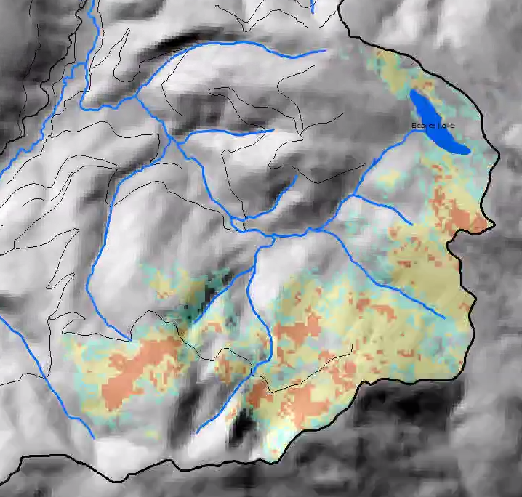
Figure 1. Colt BARC map. FNF Portion only.

Human Life and Safety: Forest Users on Roads and Trails

Risk Level: Very Low

Property: Forest Service Roads and Trails

Risk Level: Very Low. The system road was reviewed in the field along with non-system road. They were used during suppression and stabilized. No issues were found.

Natural Resources: Native Plant communities

Values at risk will be determined through the BAR program.

Natural Resources: Water Quality and Stream Habitat

The system and non-system roads would be the only potential sources of degradation to water quality or stream habitat. They have been reviewed in the field and determined to be stable.

Risk Assessment – Threats to water quality and stream habitat

Probablity of Damage or Loss: Unlikely

Magnitude of Consequence: Minor

Risk Level: Very Low

B. Emergency Treatment Objectives:

None

C. Probability of Completing Treatment Prior to Damaging Storm or Event:

Land % Channel % Roads/Trails % Protection/Safety %

D. Probability of Treatment Success

 | Years after Treatment
 | 1 | 2 | 3
Land
Channel
Roads/Trails
Protection/Safety

E. Cost of No-Action (Including Loss): $

F. Cost of Selected Alternative (Including Loss): $

G. Skills Represented on Burned-Area Survey Team:

[X] Hydrology [X] Soils [ ] Geology [ ] Range
[] Forestry [ ] Wildlife [ ] Fire Mgmt. [X] Engineering
[] Recreation [ ] Ecology [X] Botany [ ] Archaeology
[X] Fisheries [ ] Research [ ] Landscape Arch [ ] GIS

Team Leader: C. Neal Kendall
Email: craig.kendall@usda.gov Phone: 406-897-3180

H. Treatment Narrative:

I. Monitoring Narrative:

PART VII - APPROVALS

1. /s/ ________________
Forest Supervisor Date

2. /s/ _________________
Regional Forester Date

